SIMATS ENGINEERING (SAVEETHA SCHOOL OF ENGINEERING)
Department of Computer Science and Engineering
CO2_AT2 — VISUALIZATION DEVELOPMENT EXERCISE

Course Code: | DSA0606 | Course Title: | Data Handling and Visualization
CO Assessed: | CO2 – Development (BL4) | Assessment: | Assessment Tool 2 – Visualization Development
Weightage: | 20% of CIA | Total Marks: | 25 (5 Questions × 5 Marks)
CO2 Statement: | Analyze and synthesize multiple data views into a coherent, annotated dashboard that communicates a clear narrative insight.(BL4)
Student Name: | Janani Priya G | Reg. No.: | 192324041
Section / Batch: | 2023 BTech AI&DS /SLOT C | Date: | 08/05/2026

Code of Conduct
I Janani Priya G/ 192324041 (Name / Reg No) certify that this submission is my original work and that I have adhered to the guidelines specified for this assessment. I understand that any violation of academic integrity rules will result in disciplinary action.

Signature of the Student: ______Janani priya G___________________

Instructions
- This test contains 5 questions, each carrying 5 marks. Total: 25 Marks.
- No negative marking. Unanswered questions carry zero marks.
- No calculators or electronic devices permitted.
- Duration: 90 minutes.
- Each answer must include at least two coordinated charts sharing a common axis or theme.
- Include at least one annotation calling out a key data point in your dashboard.
- Write a one-sentence narrative takeaway summarizing the insight your dashboard reveals.

Annexure A – VISUALIZATION DEVELOPMENT

Problem 11 — Sports Team Performance Dashboard:
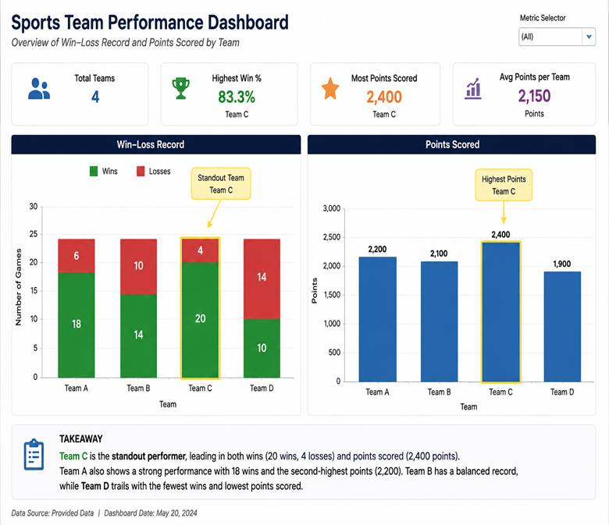
Problem 12 — Restaurant Chain Dashboard:
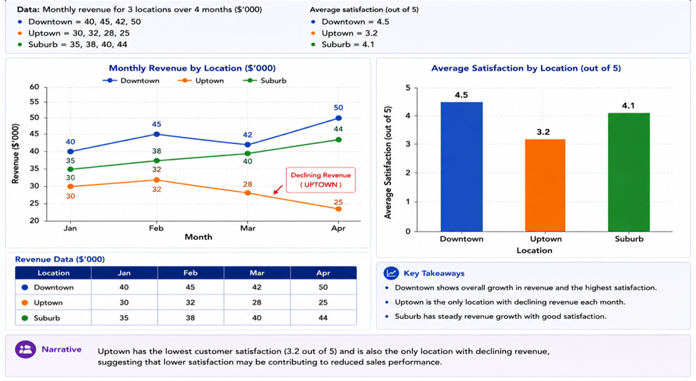

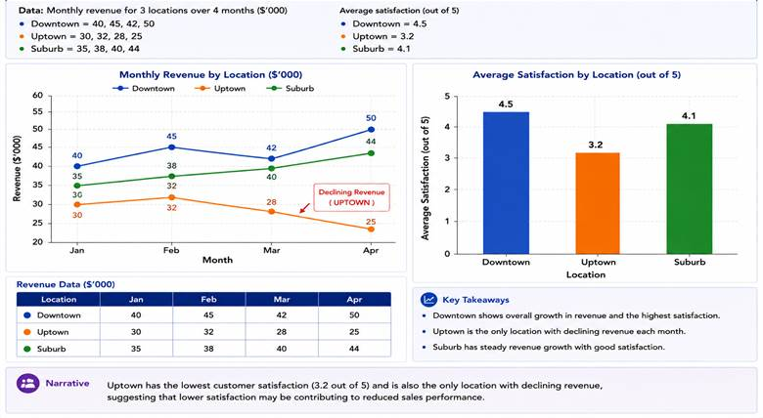

Problem 13 — App Usage Dashboard:
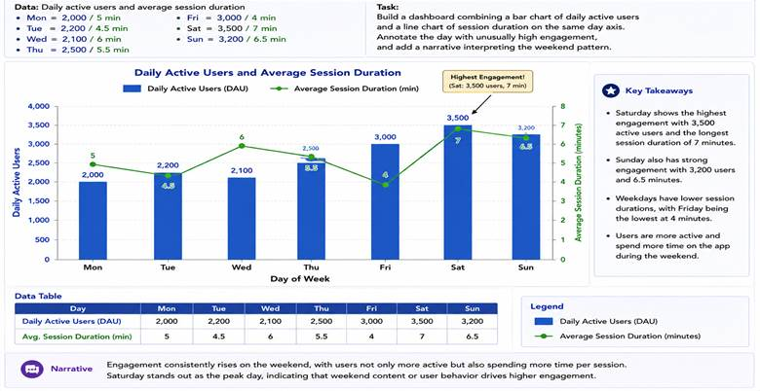

Problem 14 — Supply Chain Dashboard
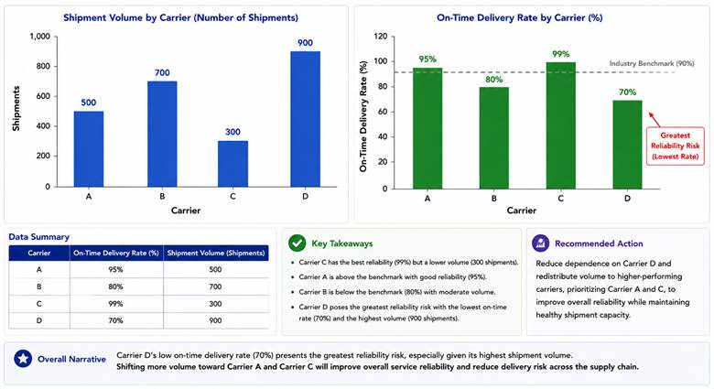
Problem 15 — University Admissions Dashboard:
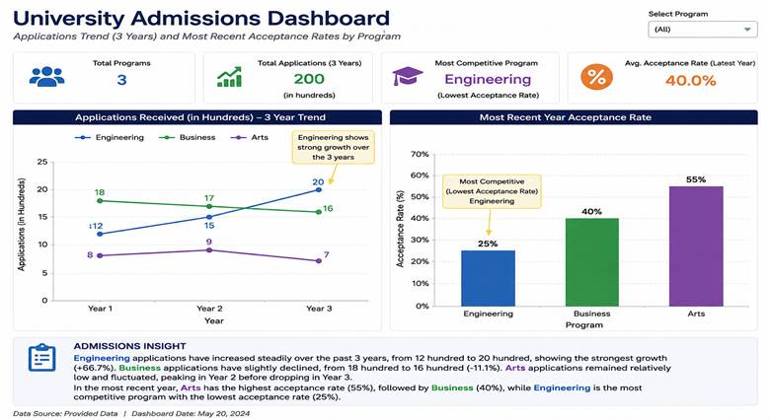



Faculty In-charge | Course Coordinator | Head of Department
Signature: _______________ | Signature: _______________ | Signature: _______________
Date: ___________________ | Date: ___________________ | Date: ___________________

